**1.INTRODUCTION**

**1.1 MOTIVATION**

Client needs a company to implement their work in an efficient manner. Companies need developers and there are many people who are interested in different domains also many developers wants to be hired with effective skills.

So the Collaborator web application acts as the platform to connect client and the company. Client pushes their requirement to the web application. The companies which are interested to take a particular work or project.

On the other hand, companies need developers and there are many people who are interested in different domains. The companies will recruit the developers according to the interest of the individual. So, everyone company, client and the developer will get benefited.

**1.2 OBJECTIVE OF THE PROJECT**

To create a web application which acts as the communication link between the Companies, Clients and Developers. Developers are required by the companies and the companies are required by the developers indeed. Clients need a company to work on their project.so this web application benefits the Clients, Companies and the developers.

**1.3 PROBLEM STATEMENT**

To develop a user friendly Web application that acts as an interface between the Companies, Clients and Developers.

**2.EXISTING SYSTEM**

**2.1 RECRUITERBOX**

Recruiterbox helps growing companies hire simply and predictably. Most recruiting software is so clunky and cumbersome that people often relapse to using email and spreadsheets. Recruiterbox intends to change that. We understand that hiring works best when people collaborate and make informed decisions together. Which is why we designed Recruiterbox to get out of your way and get this job done..

**2.2 HIREOLOGY**

The all-in-one hiring and talent management platform for businesses of all sizes. Centralize your hiring process to save time and build your best team integrations to your existing HR systems like payroll, onboarding , scheduling, And that's all been thanks to the help Hireology provided to us in creating that website.

**2.3 ULTIPRO**

It is a product of Ultimate Software which is a leading cloud provider of human capital management (HCM) applications. The award-winning **ultipro** offers HR, compensation, talent, payroll, and time and labor management apps that connect people with the resources and information they need to work more effectively.

**3.PROPOSED SYSTEM**

**3.1 METHODOLOGY**

The Collaborator is the web application which acts as the interface between the Companies Clients and the developers.

Companies, Clients and developers need to register in the corresponding category so that they will be able to get contacted from the appropriate category members.

Developers need to upload their resume so that their skills will be extracted from them for showing the same to the companies. If the company needs the person with skills then the developer will get a notification that the particular company wants to hire him.

Clients need to provide their requirements so that companies will get their details. If the company accept their proposal then the client get the notification that particular company liked your proposal and they can contact each other through mail or phone call.

All the details of the companies clients and developers are stored in the database and will be provided whenever required.

The existing systems have only hiring of the developers but not the clients collaboration. Prosposed System has both.

**3.2** **ARCHITECTURE OF PROPOSED SYSTEM**

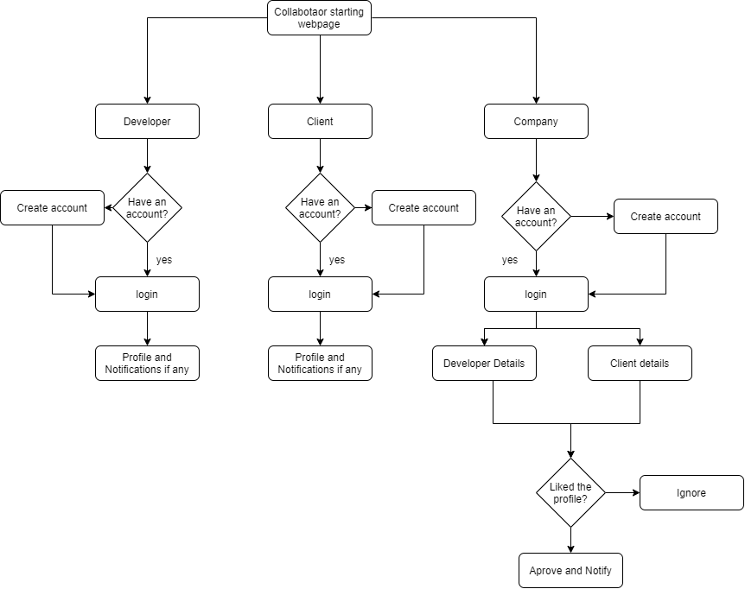

Fig 3.2.1Architecture of the proposed system.

As shown in Fig 3.2.1 The collaborator starting page has 3 categories-Developer, Client and Company. Each one has to register before login if he/she doesn’t have one. Company will get developer and client details includes the skills of the developers extracted from the resume. Client and Developers will gets notifications from Companies if any.

**4. SOFTWARE AND HARDWARE REQUIREMENTS**

### HTML

HTML stands for Hyper Text Markup Language, which is the most widely used language on Web to develop web pages. HTML was created by Berners-Lee in late 1991 but "HTML 2.0" was the first standard HTML specification which was published in 1995. HTML 4.01 was a major version of HTML and it was published in late 1999. Though HTML 4.01 version is widely used but currently we are having HTML-5 version which is an extension to HTML 4.01, and this version was published in 2012.

The <!DOCTYPE> declaration tag is used by the web browser to understand the version of the HTML used in the document. Current version of HTML is 5. There are many other declaration types which can be used in HTML document depending on what version of HTML is being used.

As told earlier, HTML is a markup language and makes use of various tags to format the content. These tags are enclosed within angle braces <Tag Name>. Except few tags, most of the tags have their corresponding closing tags.

An HTML element is defined by a starting tag. If the element contains other content, it ends with a closing tag, where the element name is preceded by a forward slash as shown below with few tags. HTML elements which don't need to be closed, such as <img.../>, <hr /> and <br /> elements. These are known as void elements. HTML documents consists of a tree of these elements and they specify how HTML documents should be built, and what kind of content should be placed in what part of an HTML document.

**CASCADING STYLE SHEET**

Cascading Style Sheets (CSS) describe how documents are presented on screens, in print, or perhaps how they are pronounced. CSS provide easy and effective alternatives to specify various attributes for the HTML tags. Using CSS, you can specify a number of style properties for a given HTML element. Each property has a name and a value, separated by a colon (:). Each property declaration is separated by a semi-colon (;). You can use CSS in three ways in your HTML document.

External Style Sheet, if you need to use your style sheet to various pages, then it’s always recommended to define a common style sheet in a separate file

A cascading style sheet file will have extension as .css and it will be included in HTML files using <link> tag.

Internal Style Sheet, if you want to apply Style Sheet rules to a single document only, then you can include those rules in header section of the HTML document using <style> tag. Rules defined in internal style sheet overrides the rules defined in an external CSS file.

Inline Style Sheet, you can apply style sheet rules directly to any HTML element using style attribute of the relevant tag. This should be done only when you are interested to make a particular change in any HTML element only. Rules defined in-line with the element overrides the rules defined in an external CSS file as well as the rules defined in <style> element.

**JAVA SCRIPT**

A script is a small piece of program that can add interactivity to your website. This script could be written using JavaScript or VBScript. You can write various small functions, called event handlers using any of the scripting language and then you can trigger those functions using HTML attributes. Now-a-days, only JavaScript and associated frameworks are being used by most of the web developers, VBScript is not even supported by various major browsers. you can keep JavaScript code in a separate file and then include it wherever it's needed, or you can define functionality inside HTML document itself. Let's see both the cases one by one with suitable examples.

External JavaScript, if you are going to define a functionality which will be used in various HTML documents then it's better to keep that functionality in a separate JavaScript file and then include that file in your HTML documents. A JavaScript file will have extension as .js and it will be included in HTML files using <script> tag.

Internal JavaScript, you can write your script code directly into your HTML document. Usually we keep script code in header of the document using <script> tag, otherwise there is no restriction and you can put your source code anywhere in the document but inside <script> tag.

**LAYOUTS**

A webpage layout is very important to give better look to your website. It takes considerable time to design a website's layout with great look and feel. Now-a-days, all modern websites are using CSS and JavaScript based framework to come up with responsive and dynamic websites but you can create a good layout using simple HTML tables or division tags in combination with other formatting tags. The simplest and most popular way of creating layouts is using HTML <table> tag. These tables are arranged in columns and rows, so you can utilize these rows and columns in whatever way you like.Multiple Column Layout, you can design your webpage to put your web content in multiple pages. You can keep your content in middle column and you can use left column to use menu and right column can be used to put advertisement or some other stuff.

**PYTHON**

Python is an [interpreted](https://en.wikipedia.org/wiki/Interpreted_language), [high-level](https://en.wikipedia.org/wiki/High-level_programming_language), [general-purpose](https://en.wikipedia.org/wiki/General-purpose_programming_language) [programming language](https://en.wikipedia.org/wiki/Programming_language). Created by [Guido van Rossum](https://en.wikipedia.org/wiki/Guido_van_Rossum) and first released in 1991, Python's design philosophy emphasizes [code readability](https://en.wikipedia.org/wiki/Code_readability) with its notable use of [significant whitespace](https://en.wikipedia.org/wiki/Off-side_rule). Its language constructs and [object-oriented](https://en.wikipedia.org/wiki/Object-oriented_programming) approach aim to help programmers write clear, logical code for small and large-scale projects.[[27]](https://en.wikipedia.org/wiki/Python_(programming_language)#cite_note-AutoNT-7-27)

Python is [dynamically typed](https://en.wikipedia.org/wiki/Dynamic_programming_language) and [garbage-collected](https://en.wikipedia.org/wiki/Garbage_collection_(computer_science)). It supports multiple [programming paradigms](https://en.wikipedia.org/wiki/Programming_paradigms), including [procedural](https://en.wikipedia.org/wiki/Procedural_programming), object-oriented, and [functional programming](https://en.wikipedia.org/wiki/Functional_programming). Python is often described as a "batteries included" language due to its comprehensive [standard library](https://en.wikipedia.org/wiki/Standard_library).

**DJANGO**

Django is a high-level Python Web framework that encourages rapid development and clean, pragmatic design. Built by experienced developers, it takes care of much of the hassle of Web development, so you can focus on writing your app without needing to reinvent the wheel. It's free and open source.

**UBUNTU 16.04 OR LATER**

Ubuntu is an open source software operating system that runs from the desktop, to the cloud, to all your internet connected things.

**POSTGRESQL**

**PostgreSQL** is an enterprise-class open source database management system. It supports both SQL for relational and JSON for non-relational queries. It is backed by an experienced community of developers who have made tremendous contribution to make it highly reliable DBMS system.

**5.IMPLEMENTATION**

**5.1 DEVELOPING BACKEND USING PYTHON**

Some important modules required:

Django: Django is a high-level Python Web framework that encourages rapid development and clean, pragmatic design. Built by experienced developers, it takes care of much of the hassle of Web development, so you can focus on writing your app without needing to reinvent the wheel. It's free and open source.

PDFMiner: PDFMiner is a tool for extracting information from PDF documents. Unlike other PDF-related tools, it focuses entirely on getting and analyzing text data. PDFMiner allows one to obtain the exact location of text in a page, as well as other information such as fonts or lines. It includes a PDF converter that can transform PDF files into other text formats (such as HTML). It has an extensible PDF parser that can be used for other purposes than text analysis.

FUNCTION TO EXTRACT SKILLS FROM A RESUME FILE:

def aftercd(request):

    dests=destination.objects.all()

    dic={}

    for i in dests:

        print(i.upload)

        filer=str(i.upload)

        # if(filer=='upload/Manideep_Laxmishetty_IT1.pdf'):

        filer='C:/Users/Manideep/Desktop/sih/media/'+filer

        pdftext=convert_pdf_to_txt(filer)

        pdftext=pdftext.lower()

           # print(pdftext)

        l=['c','c++','java','python','html','css','javascript','mysql','ms office', 'adobe xd','flash','windows','mac os','django','flask','ionic','ubuntu','android studio','unix','oracle']

        found=[]

        for j in l:

            if(pdftext.find(j)!=-1):

               found.append(j)

        # print(found)

        sfound=",".join(found)

        dic[i.name]=sfound

    print(dic)

    return render(request,"aftercd.html",{'dests':dests,'dic':dic })

**5.2 CREATING INTERFACE USING HTML AND JINJA2**

Jinja2 is a modern day templating language for Python developers. It was made after Django’s template. It is used to create HTML, XML or other markup formats that are returned to the user via an HTTP request. Jinja2 works with Python 2.6.x, 2.7.x and >= 3.3. If you are using Python 3.2 you can use an older release of Jinja2 (2.6) as support for Python 3.2 was dropped in Jinja2 version 2.7.

HTML can embed programs written in a [scripting language](https://en.wikipedia.org/wiki/Scripting_language) such as [JavaScript](https://en.wikipedia.org/wiki/JavaScript), which affects the behaviour and content of web pages. Inclusion of CSS defines the look and layout of content. The [World Wide Web Consortium](https://en.wikipedia.org/wiki/World_Wide_Web_Consortium) (W3C), maintainer of both the HTML and the CSS standards, has encouraged the use of CSS over explicit presentational HTML.

**6.RESULTS**

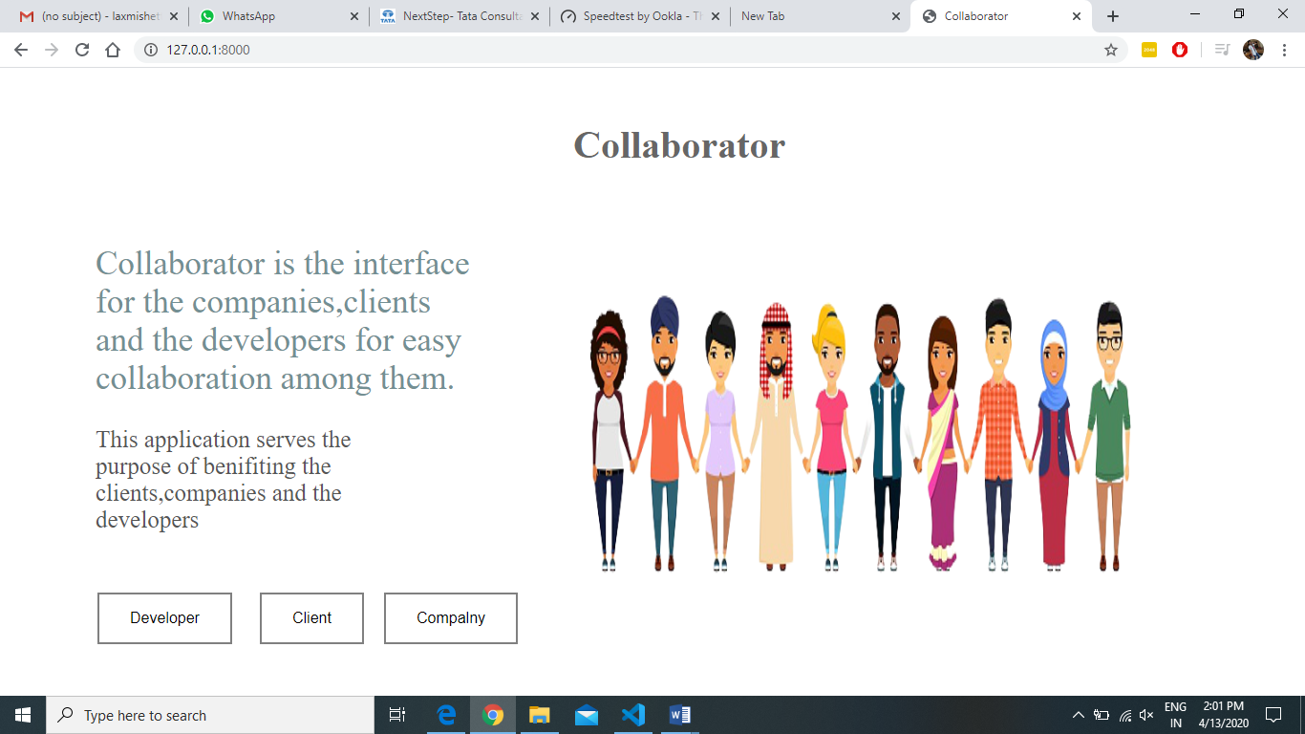

Fig 6.1 Starting webpage

As shown in Fig 6.1 will be loaded when you start the web page, It is the starting interface to select the category you want to register or login

After selecting the category the corresponding page will be loaded for the registration and login.

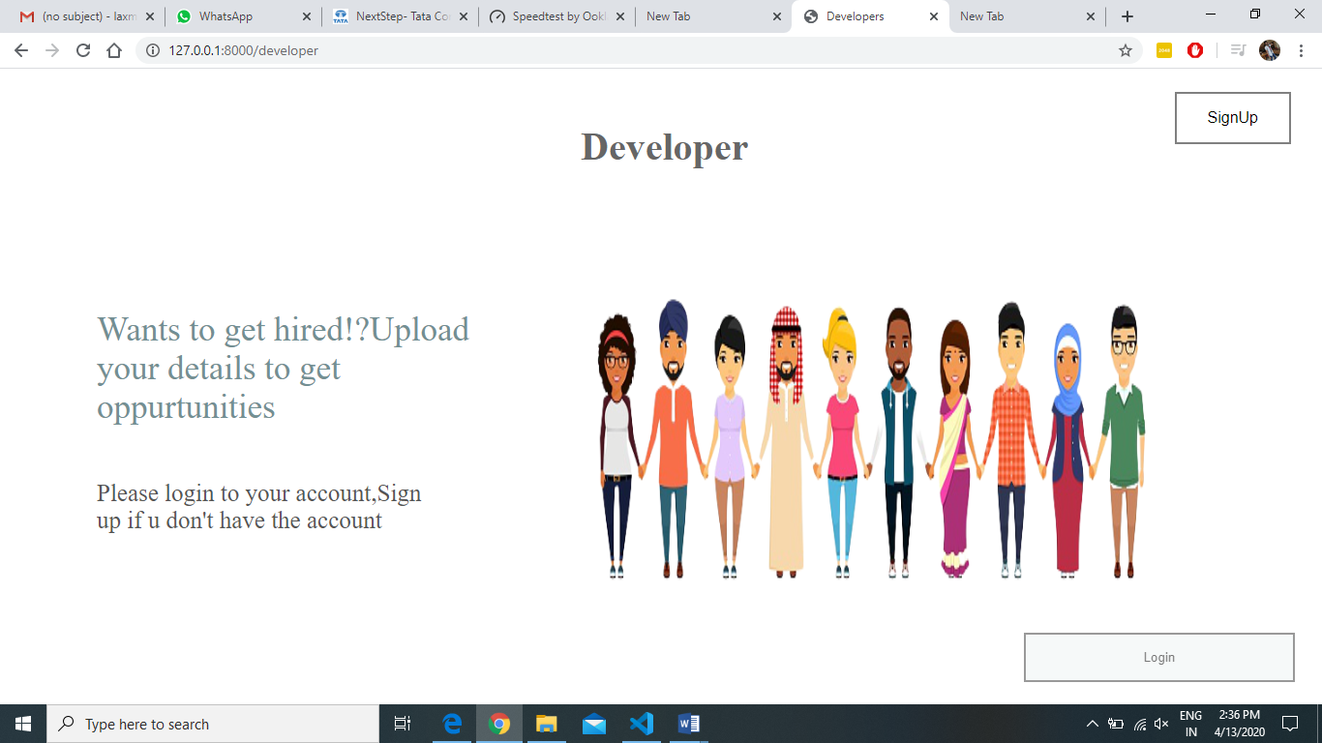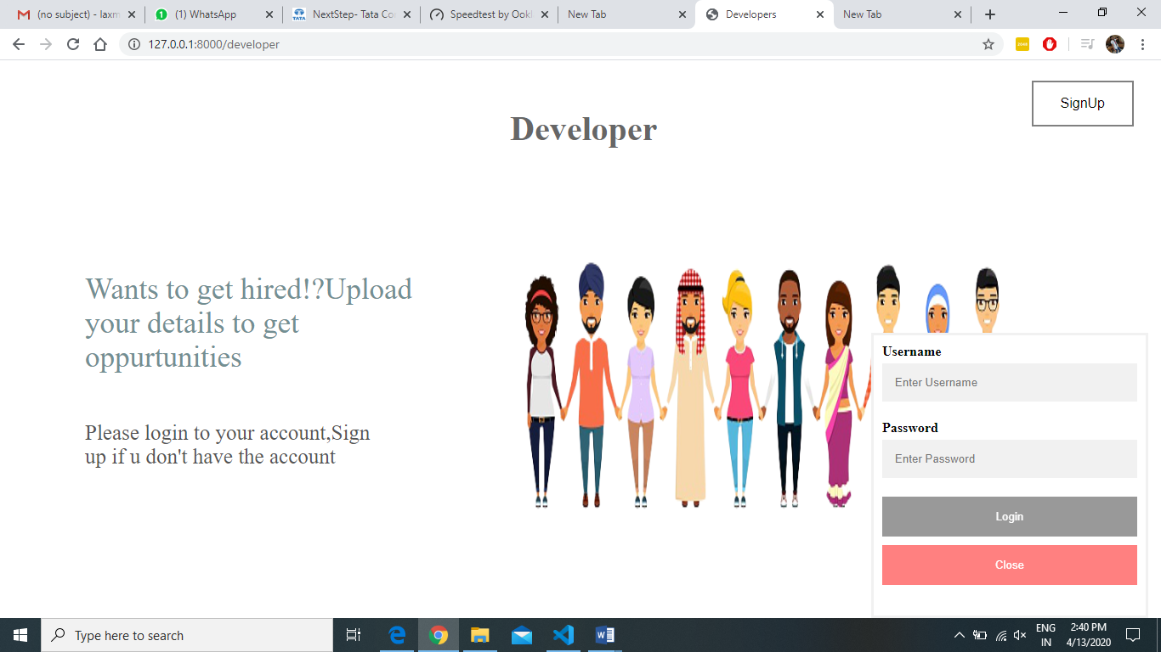

Fig 6.2 After Selecting Developer Category in starting webpage

As shown in Fig 6.2 after clicking the Developer button then you will get the above page.

If you have already registered then directly you can login through the login popup else you can register through the sign up button which will direct you to the register page.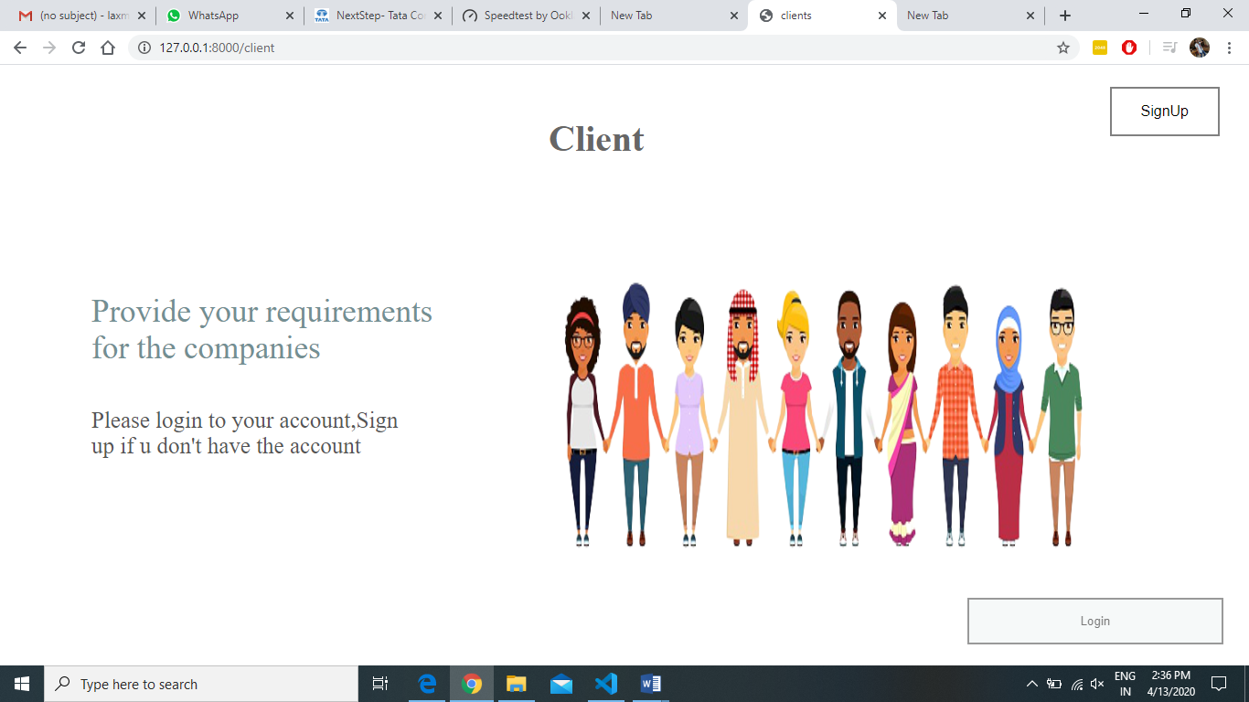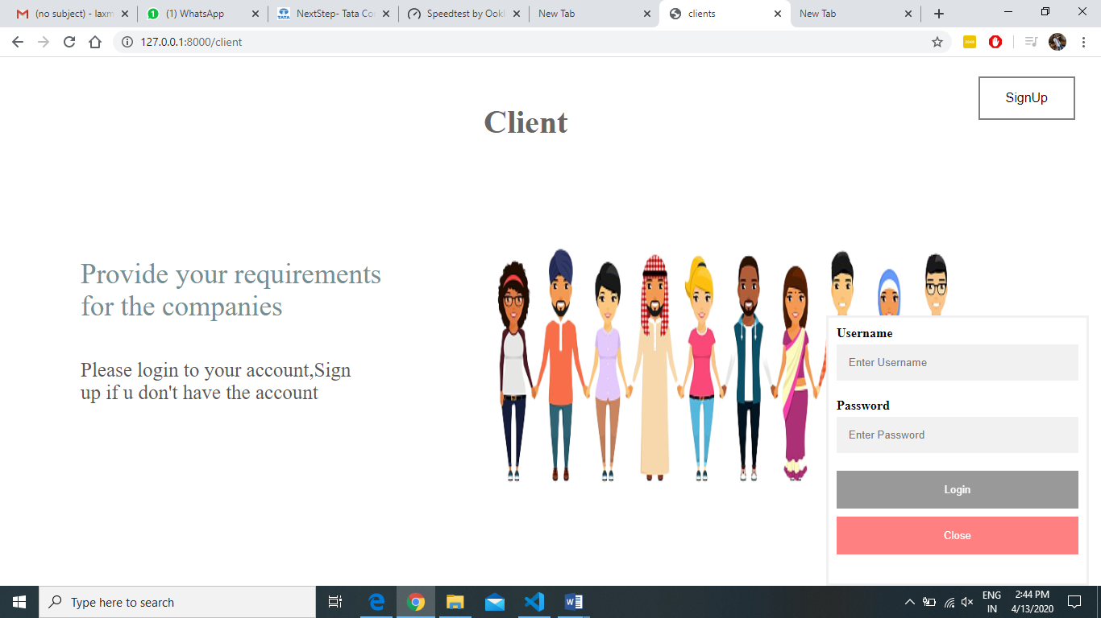

Fig 6.3 After Selecting Client Category in starting webpage

As shown in Fig 6.3 After clicking the Client button then you will get the above page.

If you have already registered then directly you can login through the login popup else you can register through the sign up button which will direct you to the register page.

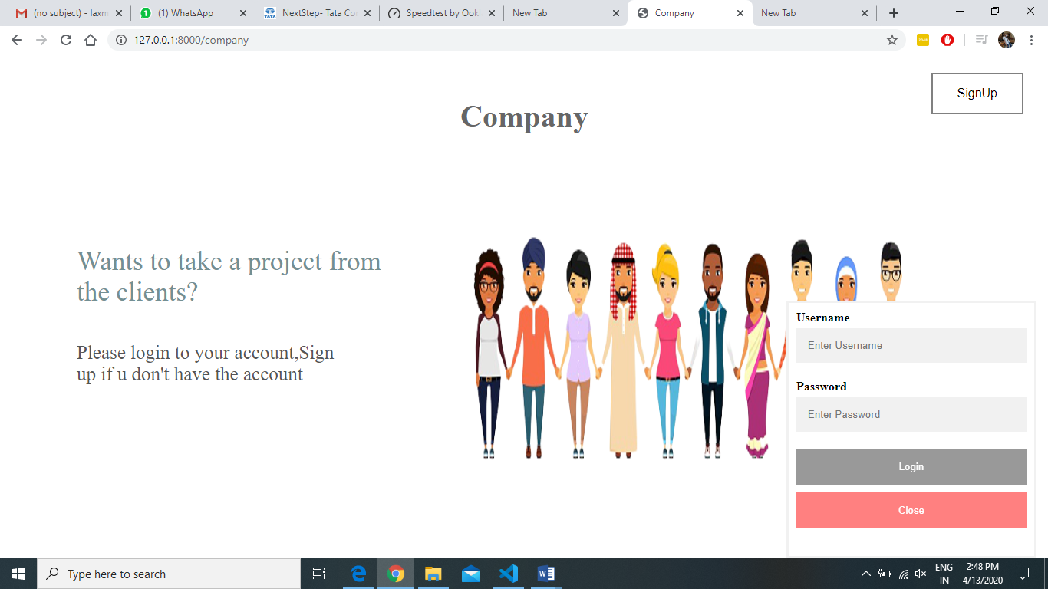 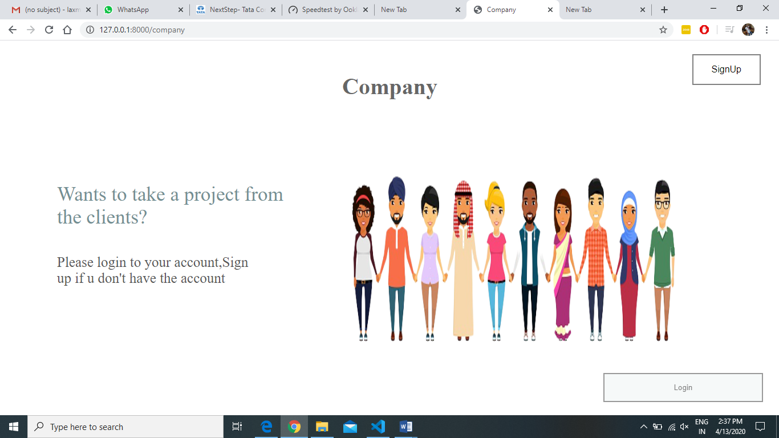

Fig 6.4 After Selecting Client Category in starting webpage

As shown in Fig 6.4 After clicking the Client button then you will get the above page.

If you have already registered then directly you can login through the login popup else you can register through the sign up button which will direct you to the register page.

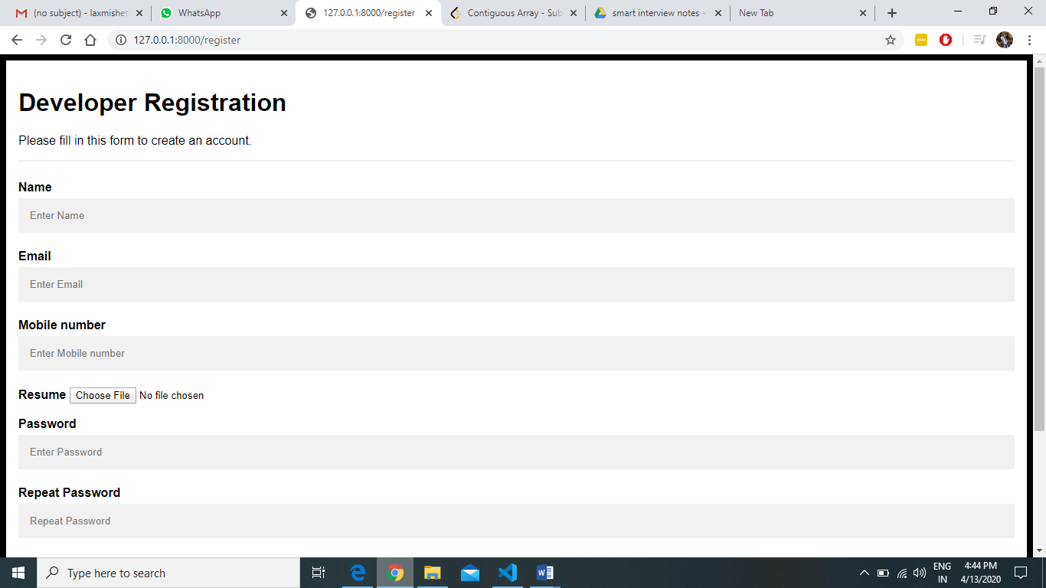

Fig-6.5 Registration page for the developer

As shown in Fig-6.5 the registration page for the developer .He need to upload the resume for the hiring process. The registration details will be stored in the database, further used for the login process.

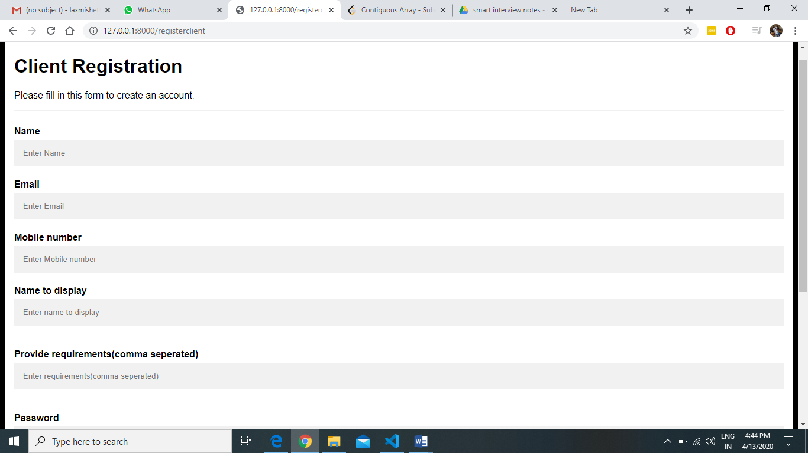

Fig-6.6 Registration page for the Client

As shown in Fig-6.6 the registration page for the Client. He need to provide the requirements.

for the companies to accept. The registration details will be stored in the database, further used for the login process.

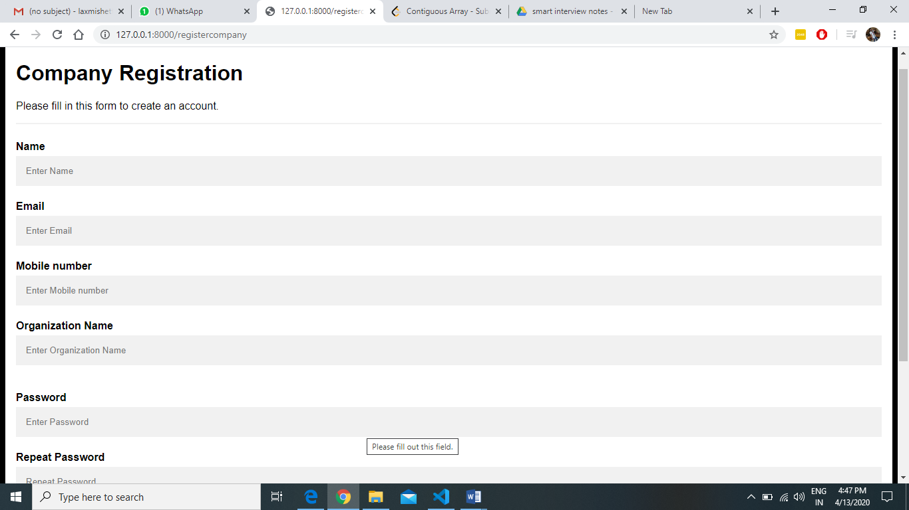

Fig-6.7 Registration page for the Company

As shown in Fig-6.7 the registration page for the Company. He need to provide the details to show to the clients and developers.

The registration details will be stored in the database, further used for the login process.

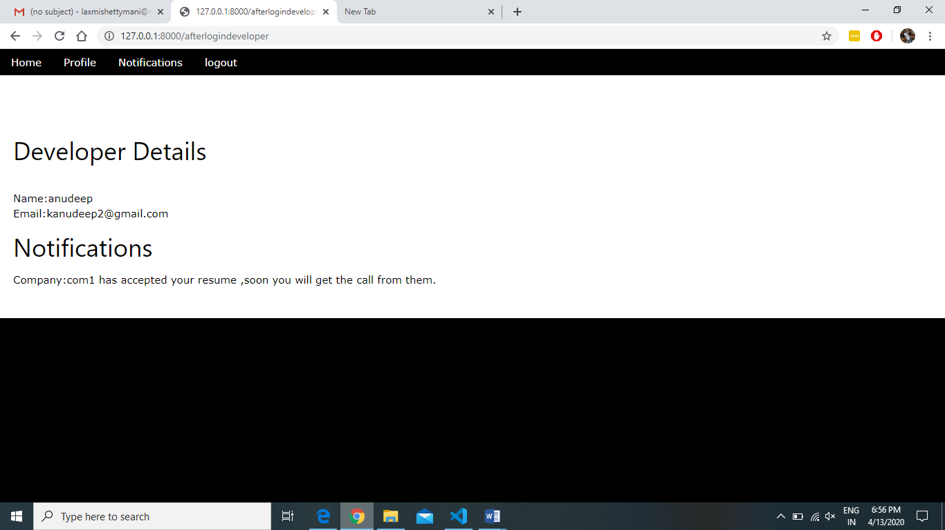

Fig-6.8 After a developer logs in.

After the developer logs in. He will be able to his profile and the notifications if any company has accepted his profile.

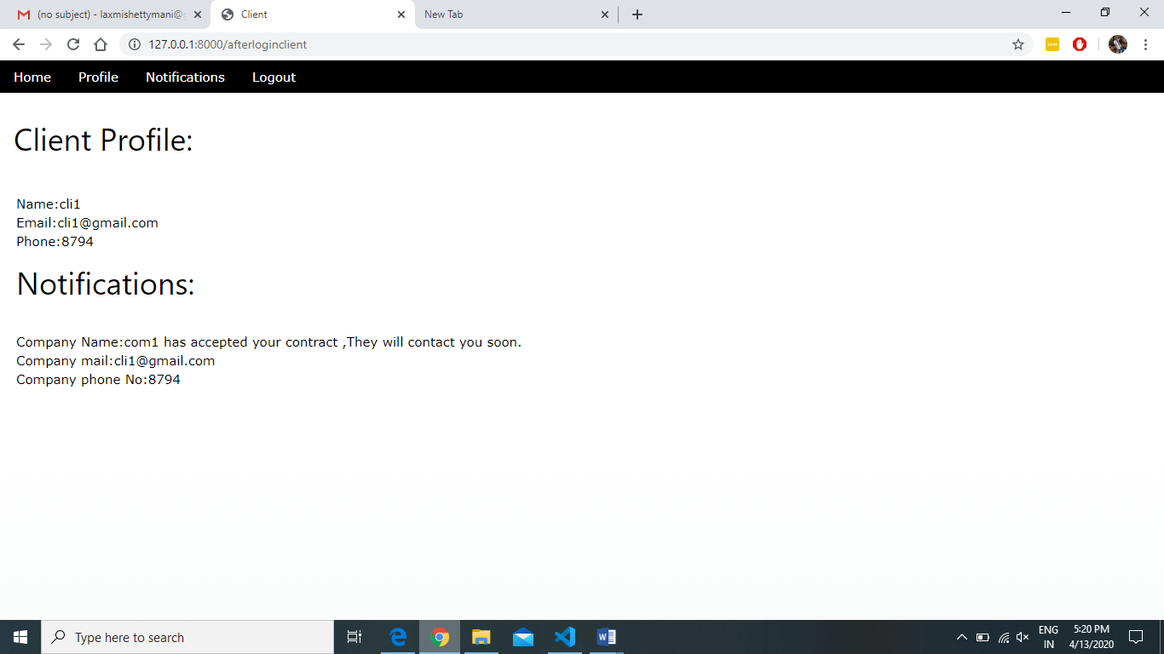

Fig-6.9 After a client logs in.

After the Client logs in. He will be able to his profile and the notifications if any company has accepted his contract.

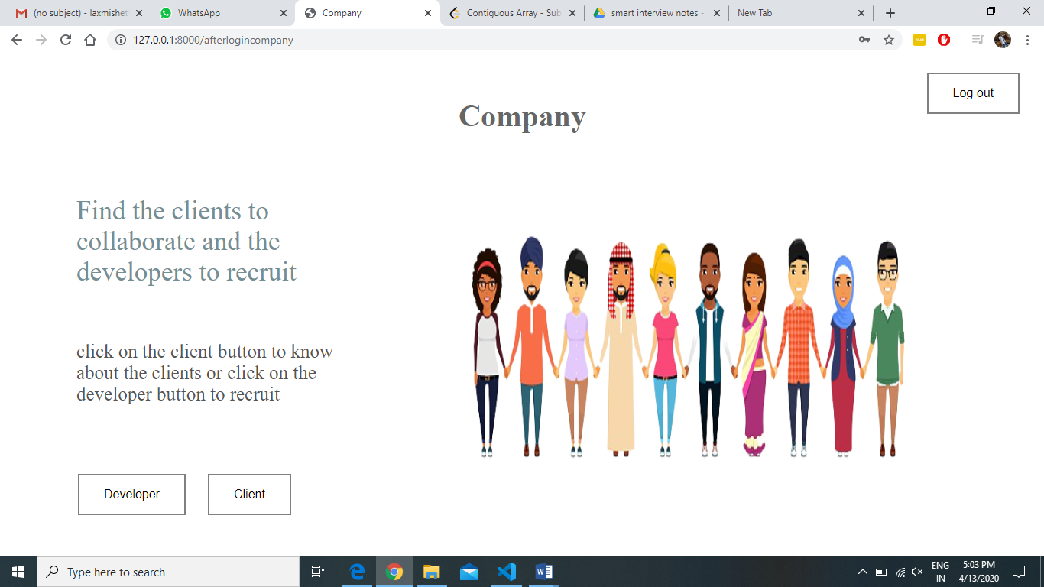

Fig-6.10 After a Company representative logs in

As shown in Fig-6.10,After the Company representative logs in. He will be able to view clients and developers profile.

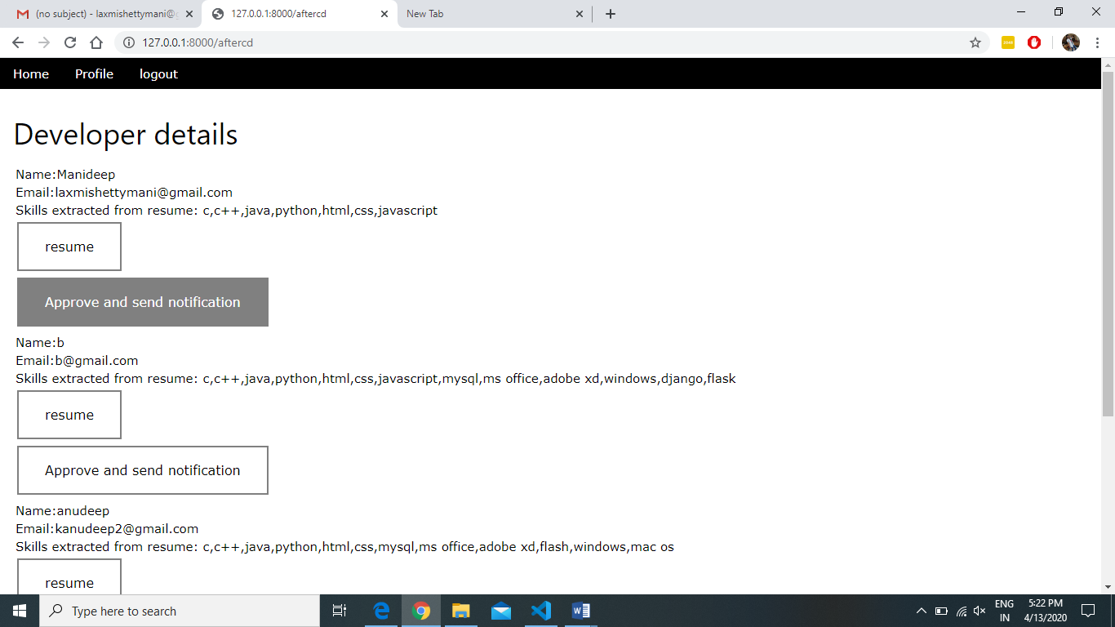

Fig-6.11 After a Company representative selects developer

As shown in Fig-6.711,After the Company representative selects developer. He will be able to view developers profile and their resume with the skills extracted from the resume.

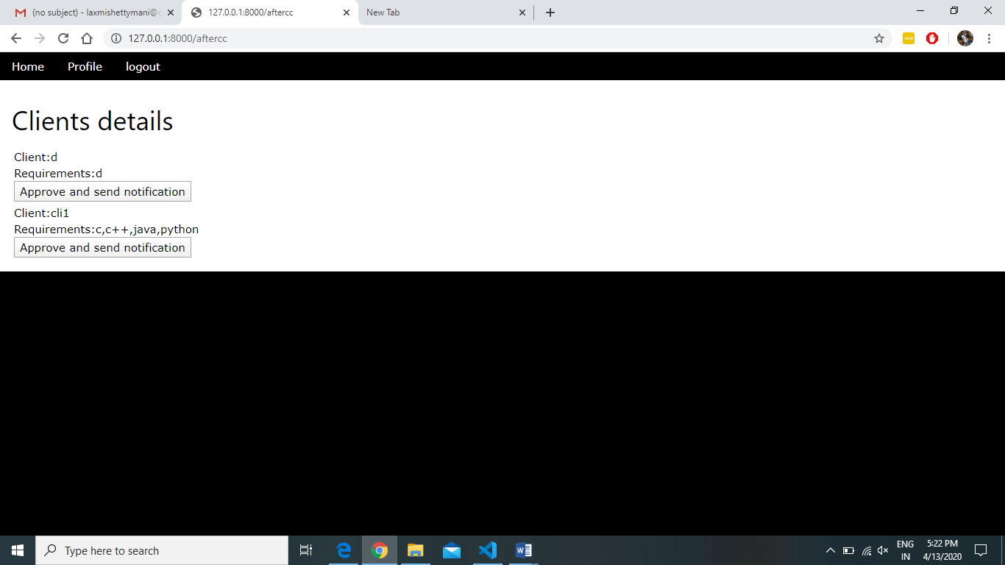

Fig-6.12 After a Company representative selects Client

As shown in Fig-6.12,After the Company representative selects Client. He will be able to view client profile and their requirements.

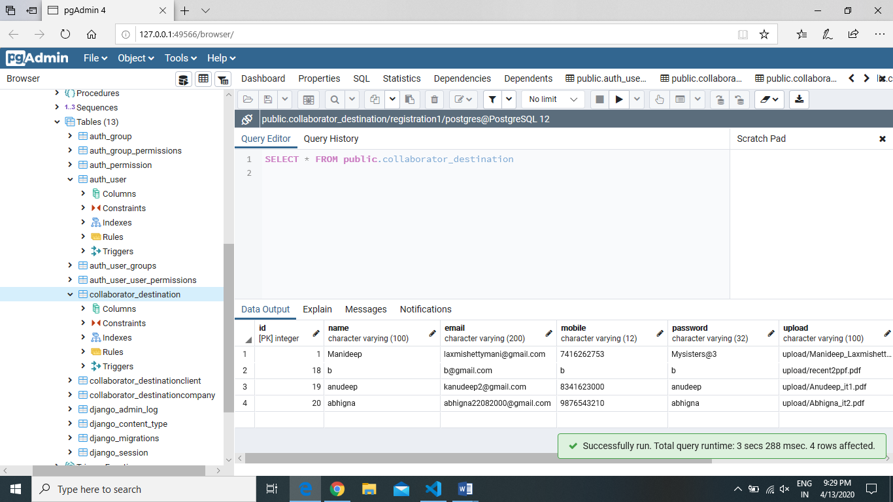

Fig-6.13 Postgresql database that stores the details

As shown in Fig-6.13,Postgresql database stores the details of the companies, Clients and companies.

**7. CONCLUSION AND FUTURE SCOPE**

The collaborator web application acts as the platform to connect client and the company. Client pushes their requirement to the web application. The companies which are interested to take a particular work or project.

On the other hand, companies need developers and there are many people who are interested in particular domain. The companies will recruit the developers according to the interest of the member. So, everyone company, client and the developer will get benefited with the user friendly collaborating application.

Many things like chat-bot, communication through messages, calls, emails can be send directly among companies, clients and developers

**BIBLIOGRAPHY**

1. <https://www.w3schools.com/js/>
2. <https://www.geeksforgeeks.org/javascript-tutorial/>
3. <https://developer.mozilla.org/en-US/docs/Learn/HTML>
4. <https://www.google.co.in>
5. <https://www.w3schools.com/>
6. <https://www.tutorialspoint.com/>
7. <https://docs.djangoproject.com/en/3.0/>
8. <https://stackoverflow.com/>